**Introduction to Bootstrap 5** Bootstrap is a powerful front-end framework that helps developers create dynamic and responsive web designs with ease. It’s like a toolbox filled with HTML, CSS, and JavaScript components that you can mix and match to create beautiful and functional web pages.

**Why Bootstrap Bootstrap offers a number of advantages:**

Speed: Bootstrap comes with ready-made coding blocks that help you set up quickly.

Responsiveness: Bootstrap’s grid system allows your website to dynamically adjust its layout based on the device screen size.

Consistency: Bootstrap ensures consistency regardless of who’s working on the project.

Customizable: Bootstrap can be tailored according to the specifications of your project.

**Bootstrap Version History Bootstrap has evolved over the years. Here’s a brief history:**

Bootstrap 1: Launched in 2011, it was known as Twitter Blueprint.

Bootstrap 2: Introduced in 2012, it added a 12-column responsive grid layout.

Bootstrap 3: Released in 2013, it adopted a mobile-first approach and introduced new components.

Bootstrap 4: Launched in 2018, it moved to Sass and flexbox for better grid system.

Bootstrap 5: The latest version as of 2021, it removed jQuery dependency and introduced new components and utilities.

**What’s included in Bootstrap 5 Bootstrap 5 comes with several components and utilities:**

Components: These are reusable pieces of code that include navbars, dropdowns, progress bars, and more.

Utilities: These are helpful classes for margin, padding, flexbox, text alignment, and more.

Layout: This includes the grid system, containers, and breakpoints for creating responsive layouts.

Bootstrap Installation To install Bootstrap, you can use the following CDN links in your HTML file:

Layouts A layout in Bootstrap is a combination of a container, rows, and columns. It’s like a skeleton on which you can build your design.

Bootstrap Layouts and Containers: Bootstrap requires a containing element to wrap site contents. Containers are used to pad the content inside of them, and there are two container classes available:

1. The .container class provides a responsive fixed width container.
2. The .container-fluid class provides a full width container, spanning the entire width of the viewport.

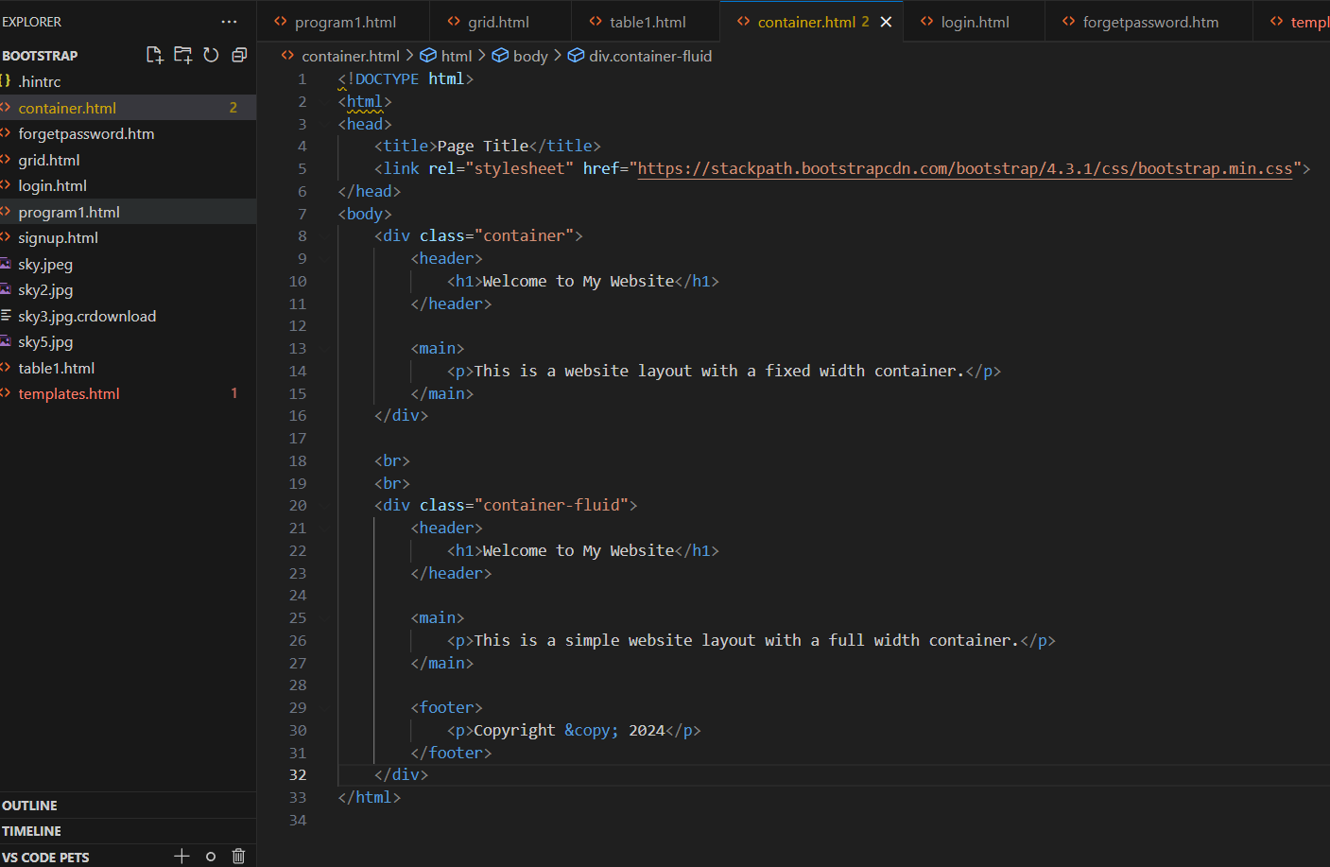



For above code the output is shown below:

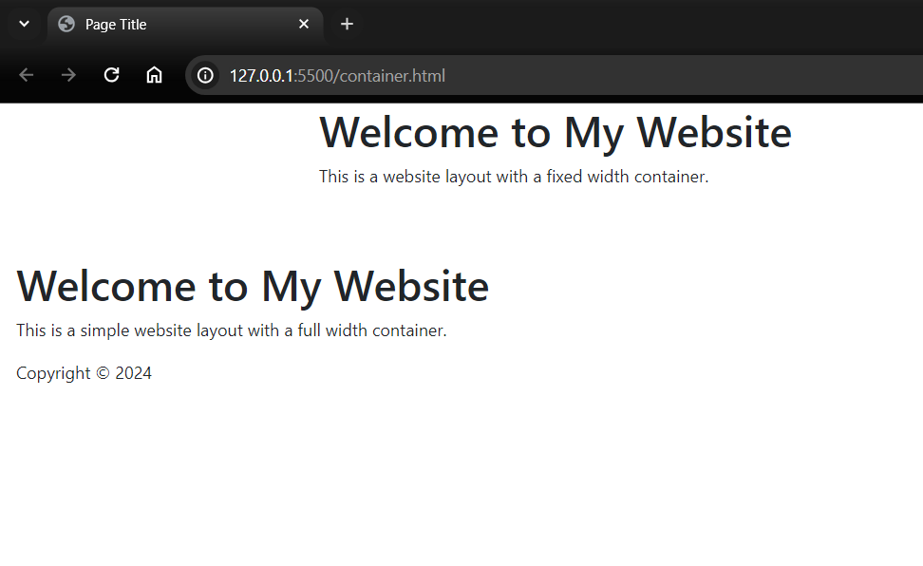

container

Container-fluid



Breakpoints: Breakpoints are the points at which your site’s content will respond to provide the user with the best possible layout to consume the information. Bootstrap 5 includes the following breakpoints: xs, sm, md, lg, xl, and xxl.

**Grid System**: Bootstrap’s grid system uses a series of containers, rows, and columns to layout and align content. It’s built with flexbox and is fully responsive. Here’s an

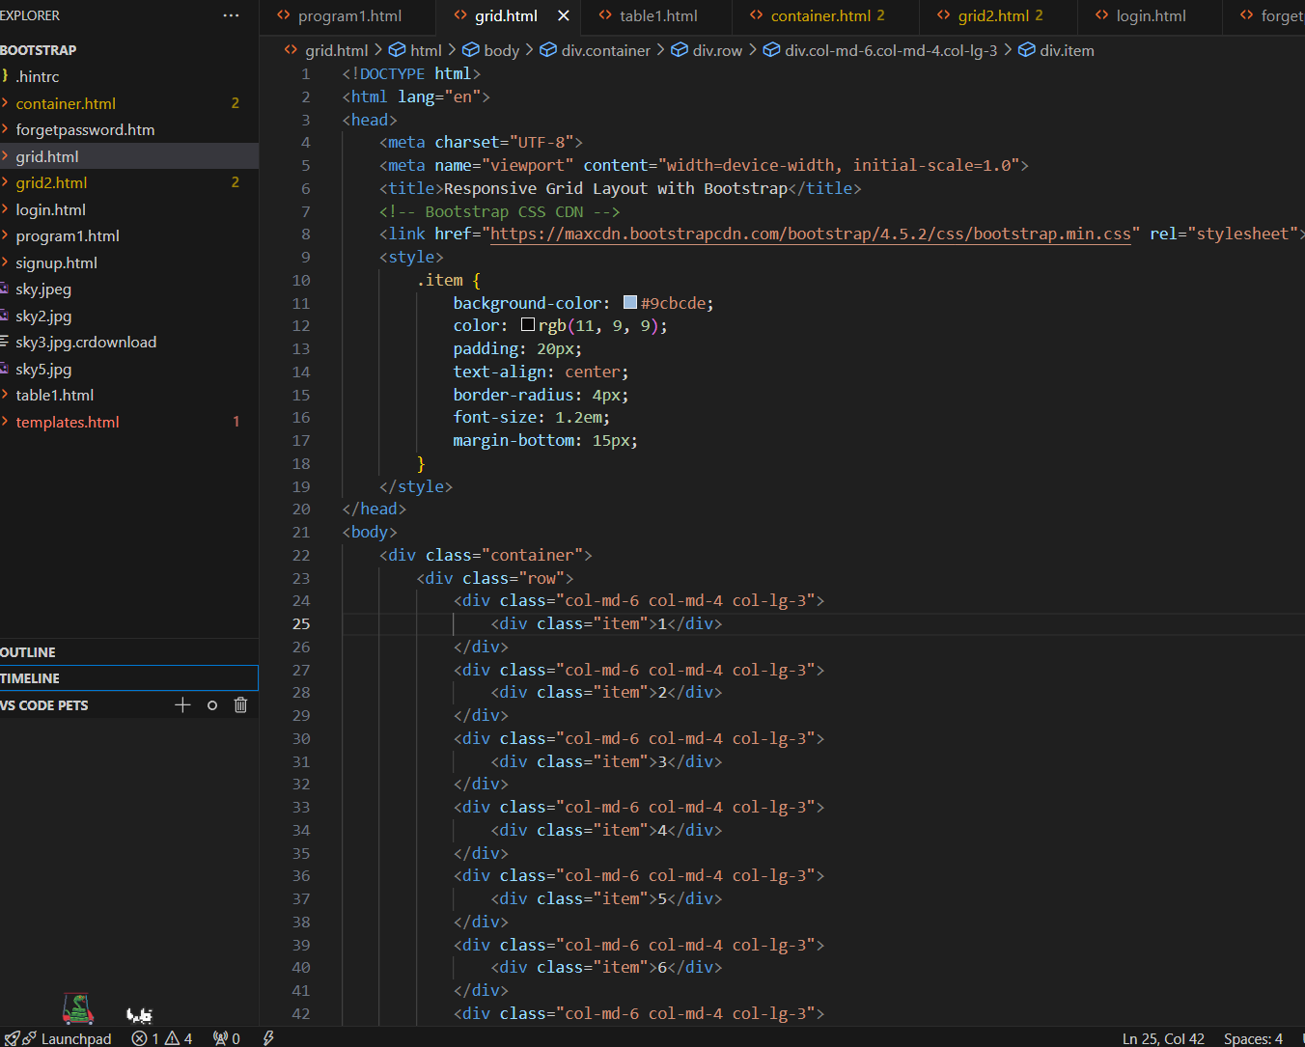

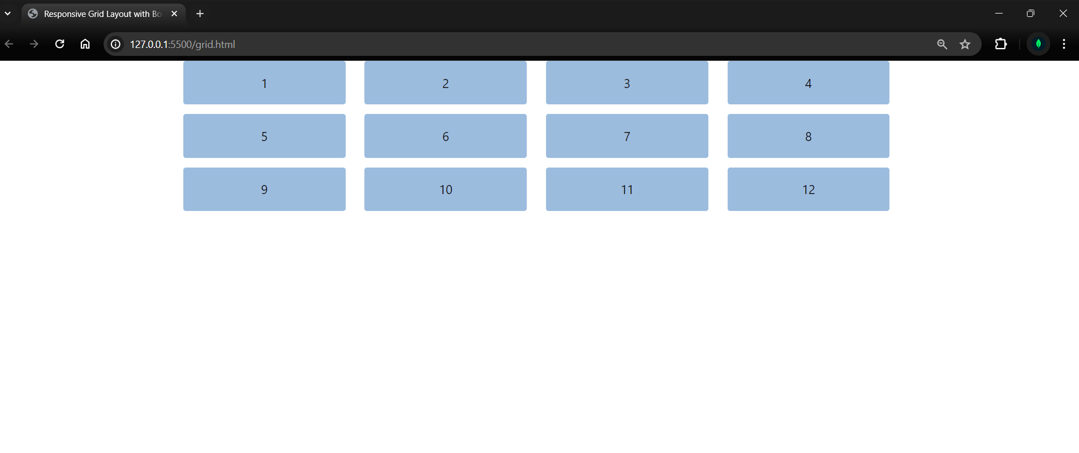

Mobile First Bootstrap 5 adopts a mobile-first approach, meaning styles are first applied to smaller screens and then scaled up for larger screens.

Column Alignment You can vertically align columns in Bootstrap using the. align-items-* classes. For example:

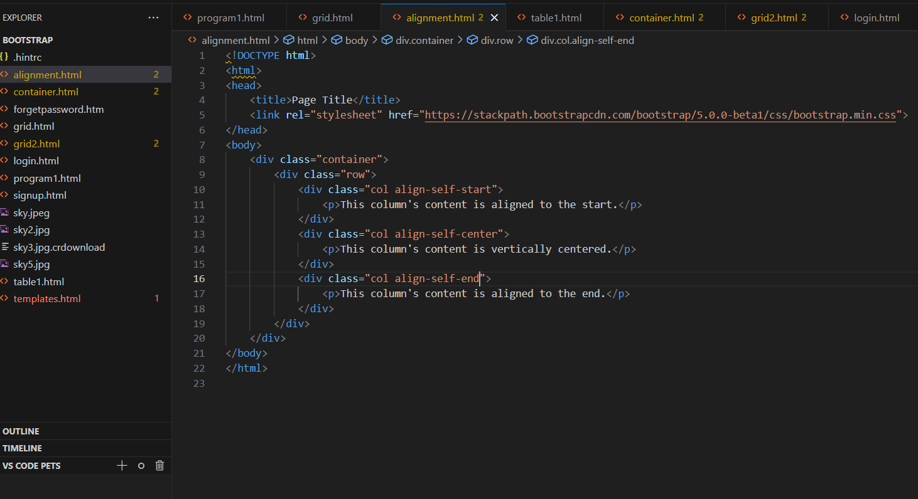

**Offsets** Offset classes allow you to move columns to the right for more precise layouts. For example:

